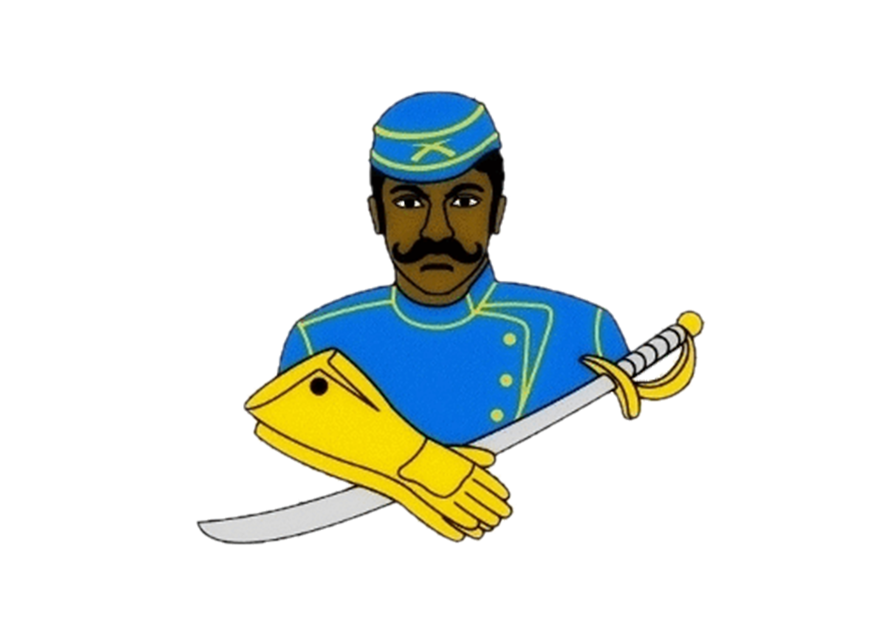
National Association of Buffalo Soldiers & Troopers Motorcycle Club (NABSTMC)
2023 Buffalo Soldiers Motorcycle Club Charlotte Scholarship Program
Scholarship Application Deadline-Charlotte: March 26, 2023

https://www.bsmccharlotte.com/

The Buffalo Soldiers Motorcycle Club of Charlotte, North Carolina creates opportunities for families, residing in Mecklenburg County, sending their children to college. The Buffalo Soldiers Motorcycle Club of Charlotte helps eligible graduating high school seniors and high school equivalency recipients, residing in Mecklenburg County, who desire to further their education and training beyond high school (community college or 4-year institution) and who demonstrate high levels of financial need. Extracurricular leadership roles in church, school or community are considered when determining scholarship winners. Winners of this scholarship will receive $1500.00 and automatically become eligible to compete for the Buffalo Soldiers Southeast Frontier Scholarship and the National Association of Buffalo Soldiers & Troopers Motorcycle Club Scholarship. One lucky winner may receive up to $9,500.00 in scholarships. Applicants will be notified if their application advances to the Southeast Frontier level and/or the National level.

Eligible scholarship application packets for the Buffalo Soldiers Southeast Frontier Scholarship and the National Association of Buffalo Soldiers & Troopers Motorcycle Club Scholarship are due April 1, 2023. It is recommended and advised that your completed scholarship application packet with attached documents be submitted to the LOCAL BSMNC Charlotte chapter on or before March 26, 2023.

The 2023 National Association of Buffalo Soldiers and Trooper Motorcycle Club scholarship application is a “fill-in” application ( https://storage.googleapis.com/wzukusers/user-35258015/documents/8a2fa30c241946ed91c69b51dbacb821/2022%20-%202023%20NABSTMC%20Scholarship%20Application%202(2).pdf) The local Chapter Name is BSMC Charlotte. Fill in all require fields of the application and save your application (usually pages 3 through 5). Completed applications and required documents must be attached as MS Word documents or scanned in a PDF format, in ONE (1) file. JPEG and GIF image formats will be rejected. Completed scholarship applications and required documents must be scanned and emailed to sloeryder@hotmail.com on or before March 26, 2023. Incomplete packages will automatically be eliminated. The BSMC Charlotte deadline for submitting applications is March 26, 2023.

Requirements of Each Applicant:
- Applicant must be a graduating High School Senior/GED/High School Equivalency recipient during the 2022 Fall / 2023 Summer school year, who will be attending post-secondary or vocational/trade school in the fall of 2023 with a minimum GPA of 2.0.
- Upload official High School Transcript, Home School Transcript, or GED/High School Equivalency test scores (no GED certificate)
- Upload a 500-word essay on the topics described below
- Upload a letter of recommendation on official letter head from a teacher/guidance counselor/school administrator
- Upload a letter of recommendation on letterhead from a community service organization
- Upload a letter of acceptance to an institution of higher learning.
- Sign Release Form.
- Parent’s signature required on release form if student is under 18 years old.
- Prepare and upload a letter of introduction, who you are, your accomplishments to date, family background, and the degree to which you are seeking, and financial need. Provide a summary on how you plan to use the scholarship if selected.
- Attach/upload a recent professional headshot photo (In Good Taste).
- Ensure you provide: (1) your full name, (2) student ID number, (3) complete name and address of the college or community college you plan to attend, and (4) address of the financial aid office of the college or community college.

Essay Topics:
Write a 500-word essay (typewritten in your own words) on one of the following topics. Create and insert a header on your document that lists your full name. **Do not write about the National Association of Buffalo Soldiers and Troopers Motorcycle Club**
- What impact did the Buffalo Soldiers make in war and/or peacetime? Why is it necessary to pass this legacy on to future generations?

- Provide specific examples of how the Buffalo Soldiers facilitated the development of roadways, national parks, and mail service.

- The Congressional Medal of Honor is presented to the recipient by the President of the United States in the name of Congress. Please provide a brief narrative regarding a Buffalo Soldier who received this honor and what can be learned from his/her life, efforts, and commitment to duty.

Completed scholarship applications and required documents must be scanned and emailed to sloeryder@hotmail.com on or before March 26, 2023. Incomplete packages will automatically be eliminated.

